Created by Tom Scotto, ICA Master Instructor

Training Type: Muscular Strength

Working HR Zones: Zones 4–5

Total Class Length: 60 minutes

**Profile Objective and Intensity:**

If you love proving that indoor cycling is not just for cardio bunnies, this is the profile for you. The duration of the intervals is short—30 to 60 seconds (with the exception of one 80-second interval). The cadence range is between ~65 and 75 rpm. The overall goal is to place as much force on the leg muscles as possible for the duration of each muscular strength interval. Unlike long (4+-minute) muscular endurance efforts, these short efforts allow for much greater stress on the legs. Consider this profile the equivalent of performing single-leg squats or lunges—800 of them!

Although the target intensity is Zone 4–5, many riders may not hit Zone 5 even though their legs are wrecked. This often occurs when a rider’s legs fail before their heart rate has the opportunity to respond. To help riders understand this response, I explain that the emphasis of the stress is on the muscular system of the legs, resulting in a Zone 5 effort for the legs and a Zone 4 effort for the lungs. Basically, the legs fail first.

**Countdown and Time Checks**

The intervals are short, but they are intense. If done correctly, each interval will bring a rider close to failure in the last seconds. It will be important to keep riders focused. Besides inspirational cues, providing time checks and a countdown can help carry your riders strongly into the final seconds. Here is an example of a 60-second interval:

*“Set your cadence and load maximum resistance. You have 60 seconds to sustain what you’ve started! 45 seconds to go! 30 seconds! 20 seconds! 15 seconds! 10! 4…3…2…1…”*

**Sustainable Power @ RPM**

Outdoor cyclists, and those addicted to high power numbers, can easily get tripped up during this workout because they many not see the output they are accustomed to. Why? As we know, power is the product of force x velocity, or cadence x resistance. Since the target cadence for each interval is relatively low, the overall power output will be lower compared to what someone may achieve during a high-intensity effort, attack, or sprint. Have riders focus on generating as much power as possible for the given cadence. For example, how many watts can they generate and sustain at 65 rpm for 30 seconds?

**Graphic Profile**

(Provided by Class Builder™)

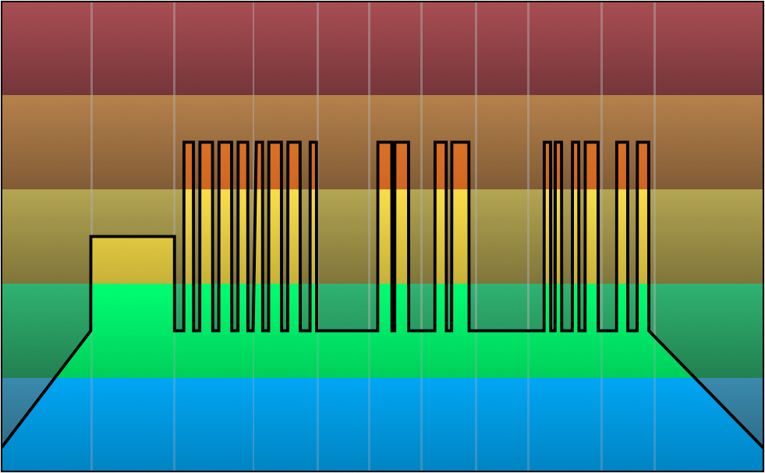

**Coaching**

**Intro / Warm-Up**

**Hypnotized, P.R.O.M., 7:04, 88 bpm**

As riders move through the warm-up, I take extra care to encourage proper form. The potential stress on the body during maximum strength efforts requires the proper alignment of joints for maximum effectiveness without the risk of injury. It is also important to emphasize the need for riders to listen to and obey their body’s response to the stress. It is mandatory that riders consider existing injuries, pain, and unusual discomfort when determining how much resistance they apply or how many intervals they complete.

*Yet another class of extremes! Our goal is to apply as much resistance as possible for each interval while still maintaining the target cadence.*

*The cadence will be slow, resulting in maximum torque on the legs. Fun!*

*As always, listen to your body and be wise with injuries, pain, or discomfort. Only add the amount of resistance you can handle. If the cadence is too slow, choose a faster leg speed to reduce the stress on the legs.*

*Choose quality over quantity. If you are in the middle of a set and you feel you cannot complete the next interval successfully, skip it and recover. Four excellent intervals are more effective than eight mediocre ones.*

**Warm-Up—Accelerations**

**Main Springs, Shen, 6:34, 104 bpm**

Before we start the first set of intervals, riders should experiment with their cadence and the amount of force they legs are able to handle TODAY. Ask riders to add resistance to slow their cadence to 50–55 rpm. Without removing the cadence ask them to accelerate to 2x their speed within 15 seconds. After each acceleration, riders can choose to either back off the resistance to an easy road or retain the resistance they added and only reduce their cadence back to 50–55 rpm. Leave the final 2 minutes to recover for the first set.

*It is time to prepare the legs for the stress of muscular strength intervals. Begin adding resistance until your legs are forced to slow to the rhythm of the music or 50–55 rpm. This will help activate the muscles.*

*We are going to perform a number of short, 15-second accelerations, pushing through this resistance. Try to remain relaxed. Do not wrestle the bike, but rather focus on using the muscles between the hips and knees (hip flexors, glutes, quads, and hamstrings).*

*Take this time to experiment with the amount of force your leg muscles are able to handle. If your body is moving excessively and you are pulling on the handlebars to turn the pedals, you have too much resistance.*

**SET 1: Seated Strength Intervals (8)**

**Ghosts N Stuff, deadmau5, 6:10, 63 bpm**

**Time, Rundfunk, 5:05, 65 bpm**

Set 1 offers eight muscular strength intervals at ~65 rpm. The goal is to add as much resistance as possible while maintaining proper form and a cadence above 65 rpm. Riders should return to an easy road between intervals (30–45 seconds of intermediate recovery) to maximize each effort.

*This is our first set of intense muscular strength work. You may still be working out what your body can handle. That is wise. Use the first four intervals of this eight-interval set to dial in your resistance.*

*Let’s figure this out. I’m going to count you into and out of each interval so you know exactly when to start and stop. Start adding resistance. We are going to try to achieve our three Fs for each interval: resistance you can FEEL, resistance you are forced to FIGHT, resistance that causes you to FAIL.*

*The fear of FAILURE should rear its ugly head during the last 5 seconds of each interval. Keep making adjustments until this fear exists.*

*Think STRONG! Think POWERFUL! Think UNSTOPPABLE!*

**Interval Timing:** Ghosts & Stuff

* 0:45 – 1:29 (45 seconds)
* 2:00 – 2:59 (60 seconds)
* 3:30 – 4:29 (60 seconds)
* 5:00 – 5:45 (45 seconds)

**Interval Timing:** Time

* 0:15 – 0:44 (30 seconds)
* 1:14 – 2:00 (60 seconds)
* 2:44 – 3:41 (60 seconds)
* 4:29 – 4:58 (30 seconds)

**Recovery / Flush the Legs**

**Plain Speaking, Ashtech, 4:02, 120 bpm**

It should take riders 1.5 to 2 minutes to recover to Zone 1 or 2 after each set. If they can recover in a minute or less, this is an indication that they are not maximizing each interval. After 2 minutes, perform two to three easy 15- to 20-second accelerations (not to exceed 120 rpm) to flush the legs.

*Back off the resistance and return to an easy road. Choose a comfortable cadence.*

*I’ll give you 2 minutes to restore your heart rate/breathing before performing a few short accelerations to flush the legs. FYI, if you were able to recover from that set in less than a minute, it is time to work harder. ☺*

**SET 2: Standing Strength Intervals (4)**

**Scary Monsters and Nice Sprites, Skrillex, 4:03, 70 bpm**

**First of the Year (Equinox), Skrillex, 4:21, 74 bpm**

Set 2 provides some longer intervals but at a faster cadence (70–75 rpm). In addition to a faster cadence, the intervals are to be performed standing. The goal is still the same: how much resistance can riders handle without slowing below 70–75 rpm? Standing intervals will allow riders to place more resistance on the bike (to compensate for their body weight), can produce higher heart rates, and the faster cadence usually provokes a greater aerobic response from the body.

**Musical Note** (no pun intended): When I introduce a different genre of music, I like to prepare my riders for the “experience.” The two songs for this set are dubstep. I’ll let you look up all the cool facts about this genre on Wikipedia. Dubstep is very percussive and rhythmic. The chorus, if you will, known as “the drop,” is very industrial and machine-like, with a heavy dose of sub-bass. It can sound like the native tongue of extraterrestrials.

*Welcome to set 2. Prepare your mind for four muscular strength intervals…STANDING!*

*If you cannot stand, or don’t want to, continue performing the intervals just as we did in set 1.*

*I’m going to add another “F” to the original three. Before your mind goes to a dark place, it is FORCE. I want you to add resistance you can FEEL, then enough to FORCE you out of the saddle. Then feel free to FIGHT and FAIL as usual.*

*Just a heads-up: there are only 15 seconds of intermediate recovery between the first and second interval, 2 minutes after the second, and 30 seconds after the third.*

*Interval #1 is coming at you. 4…start loading resistance…3…FEEL the resistance slowing your legs…2…add enough resistance to FORCE you to stand…1…FIGHT!*

*Stay STRONG! Maintain your form and remember the technique that will save you!*

*Power the bike with the hip flexors as you pull up and over, the glutes at the top of the stroke, the quads to crush the downstroke, and the hamstrings as you push through the bottom of the stroke.*

**Interval Timing:** Scary Monsters & Nice Sprites

* 0:40 – 1:45 (60 seconds)
* 2:00 – 3:04 (60 seconds)

**Interval Timing:** First of the Year (Equinox)

* 1:06 – 1:58 (50 seconds)
* 2:25 – 3:45 (80 seconds)

**Recovery / Flush the Legs**

**Plain Speaking, Ashtech, 4:02, 120 bpm**

[Same song and basic spiel as the earlier recovery]

*The purpose of this kind of workout is to apply enough stress to the muscles to cause the body to adapt. If inadequate stress is applied to the legs, there is little need for the body to recruit additional resources or increase strength to overcome the challenge.*

*Just to be clear, the stress we are referring to is “eustress” and not “distress.” The origin is from the Greek “eu” (for some reason,* My Big Fat Greek Wedding *popped into my mind), which is interpreted as “well” or “good.” Eustress is stress that is beneficial. “Distress” is all the crap and mental junk we gathered throughout the day—which you are required to leave at the door before entering class.*

**SET 3: Mixed Strength Intervals (6)**

**Get Loose (Tiesto Remix), Showtek & Noisecontrollers, 5:43, 65 bpm**

**Stampede, Dimitri Vegas, Like Mike, DVBBS & Borgeous, 4:17, 64 bpm**

The last set of intervals brings the cadence back to 65 rpm. The first four intervals alternate between seated and standing. The last two intervals are a combo. The fifth and sixth intervals start with a seated muscular strength max effort. Riders are then challenged to add more resistance to force them to complete the last 15 seconds standing.

*The last set of work is upon us. The question we must ask is NOT what we have left to give, but will we give what is left?*

*As your body screams of fatigue, it is critical that we reconnect with our form. It can be tempting to forgo technique and resort to brute strength. Not only will this NOT produce the power you desire, but can place your muscles and joints at risk. Give all you have, as long as you can maintain good form in the process.*

[As the song Stampede begins]

*There are two intervals left. They are 50 seconds each. They start seated and force you out of the saddle for the last 15 seconds.*

*This song is the title track of today’s class. It is called “Stampede”!*

*You are no longer in an indoor cycling (or Spinning®) class. You are no longer on a bike. You have been transported to the jungle. You have been transformed into a wild beast: a wild beast of your choice. I’m going to add one more “F”—FIERCE!*

*During each of these last two intervals you will be a FIERCE beast, in a stampede, crushing everything in your path. Each pedal stroke will shake the ground.*

*You are POWERFUL! You are a FORCE! You are FIERCE! STAMPEDE!!!*

**Interval Timing:** Get Loose

* 1:17 – 1:46 (30 seconds)
* 2:09 – 2:38 (30 seconds)
* 3:30 – 3:59 (30 seconds)
* 4:30 – 5:30 (60 seconds)

**Interval Timing:** Stampede

* 1:15 – 2:06 (50 seconds)
* 2:52 – 3:45 (50 seconds)

**Cool-Down / Stretch**

**Hope, Scann-Tec, 8:32, 82 bpm**

Final Thoughts:

If your riders are not accustomed to max strength efforts, this workout may have been eye-opener (and a leg-breaker). Profiles that push the limit can draw attention to a rider’s bike setup. Encourage riders to speak to you if they have questions about their power (if you have meters in your class), or any pains or discomfort they may have experienced during the ride.

*I hope everyone enjoyed the ride. If you legs are wobbly and wasted, they should be. You performed the equivalent of approximately 800 single-leg squats or lunges.*

*That being said, if I catch you working out on a leg machine after class, I will hurt you.*

**Music Profile**

|  |  |  |  |  |
| --- | --- | --- | --- | --- |
| Section | Music | | BPM | Time |
| Intro / Warm-up | Hypnotized, P.R.O.M. | 88 | | 7:04 |
| Warm-Up: Accelerations | Main Springs, Shen | 104 | | 6:34 |
| SET 1:  8 Seated Intervals | Ghosts N Stuff, deadmau5  Time, Rundfunk | 63  65 | | 6:10  5:05 |
| Recovery / Flush Legs | Plain Speaking | 120 | | 4:02 |
| SET 2:  4 Standing Intervals | Scary Monsters and Nice Sprites, Skrillex  First of the Year (Equinox), Skrillex | 70  74 | | 4:03  4:21 |
| Recovery / Flush Legs | Plain Speaking | 120 | | 4:02 |
| SET 3:  6 Mixed Intervals | Get Loose (Tiesto Remix), Showtek & Noisecontrollers  Stampede, Dimitri Vegas, Like Mike, DVBBS & Borgeous | 65  64 | | 5:43  4:17 |
| Cool-Down / Stretch | Hope, Scann-Tec | 82 | | 8:32 |